## Lesson 15 – Activity Sheet

## Getting Started

The micro:bit has a built-in **magnetometer** that measures magnetic field strength in each of the three axes: *x*, *y* and *z*. The earth has a magnetic field and by taking readings it is possible to create a **compass**.

First the micro:bit has to be calibrated using the following program:

from microbit import *

compass.calibrate()

Download the program to your micro:bit. During calibration the program will pause while it takes readings and makes adjustment. Rotate the micro:bit until all the LEDs are lit. This means that the required readings have been taken and the compass is set and ready to use.

## **Creating a Compass**

Once the compass is calibrated, we can use a program to create a real time compass display. This takes a reading using the magnetometer and stores result in a variable named needle. The we divide the reading by 30 as the total degrees in a circle has 360 degrees and dividing by 30 gives us four directions for each quarter of the LED display. This means we can display 12 directions.

from microbit import *

compass.calibrate()

while True:

needle = ((15 - compass.heading()) // 30) % 12

display.show(Image.ALL_CLOCKS[needle])

The program then calls display.show() function and passes the data stored in the needle variable to the function. This results in a ‘needle’ indicating the direction of North.

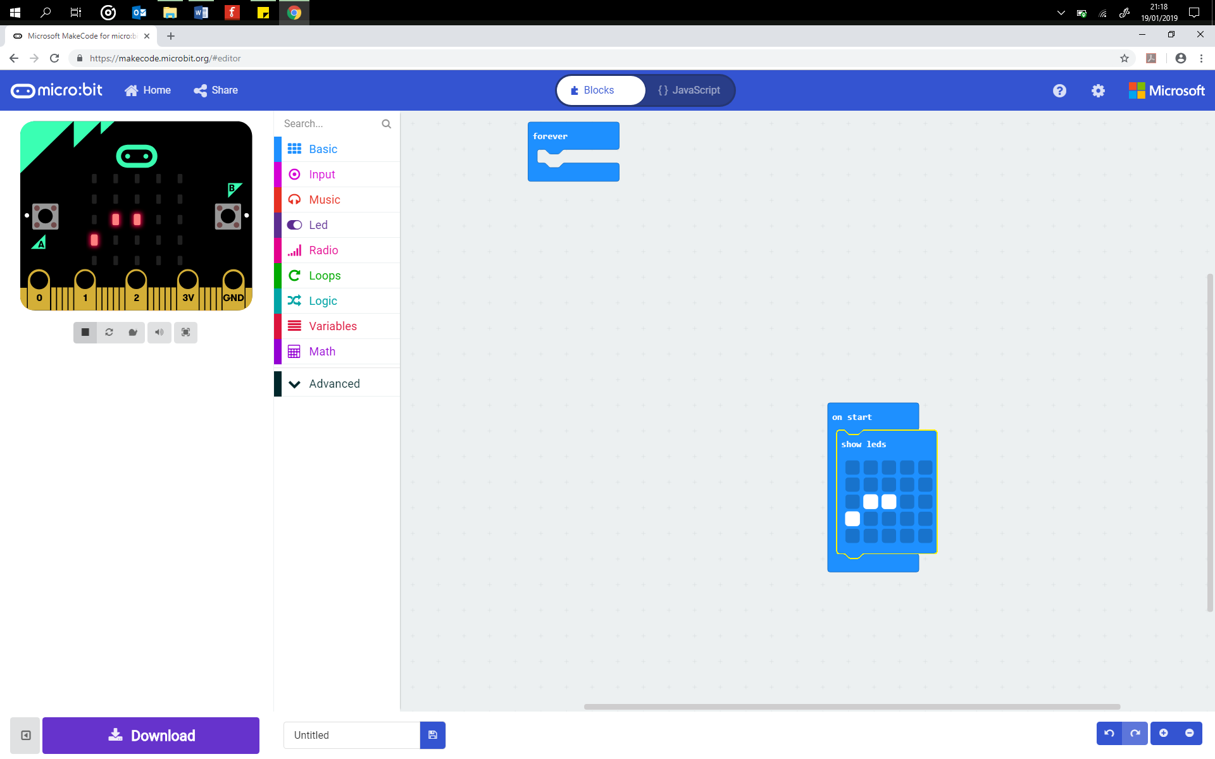

## **The Treasure Hunt**

You are going to hide an object and write a set of instructions for another student on how and where to find it using the micro:bit compass. Attach the battery pack so that you can move away from the computer.

Follow the instructions below

1. Begin by standing in your starting position
2. Write down the starting position. *(‘Stand in front of the blue door’)*
3. Turn and face the direction you will be walking in, take note of the compass direction on your micro:bit
4. Record the direction and how many steps you walk
5. Record this as an instruction (*‘Walk west 15 steps’)*
6. Turn and face a new direction and take note of the new compass direction, walk forward
7. Record this as the next instruction (*‘Face north east and walk west 26 steps’)*
8. Continue until you have reached the location where you will hide the object. Place it down
9. Give the list of instructions to another student and see if they can find your hidden object

The list of instructions will look similar to this:

1. *Stand in front of the blue door*
2. *Walk west 15 steps*
3. *Face north east and walk west 26 steps*
4. *Look West and you will see the hidden object*

## Success Criteria

* Program and use the micro:bit compass
* Hide an object and write at least 5 instructions
* Write at least 10 instructions
* Write at least 15 instructions

## Pro-tip

When using the micro:bit as a compass ensure that it is away from metals and other magnetic sources such as hard drives, magnets and phones. These will not damage the micro:bit but they will interfere with the measurements and return incorrect results and measurements.

## Test Time

Download the compass code and move around the room facing in different directions. Get another learner to follow your treasure hunt instructions, can they find the hidden object? Remember to calibrate the compass to ensure the directions are accurate.

## Stretch Tasks

* Instead of telling the student the compass direction – west, north etc. – you could draw a diagram of how the direction is indicated on the micro:bit and let them figure it out.

## 



## Walk 23 steps Walk 12 steps Walk 17 steps

## Final Thoughts

Even though much of today’s navigation is supported by GPS, a compass can be used to determine magnetic north and then orientate a map in the right direction. It can also be used to determine the azimuth of an object, which is the direction of an object in the sky measured in degrees. This value corresponds to four directions on earth, North, East, South and West.